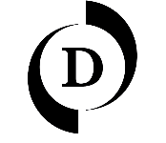
D Contemporary

PRESS IMAGES
Rômulo Avi — Arcadia and a new commission for Cedars-Sinai London
Captions, credits and usage terms
High-resolution images available on request from irene@dcontemporary.com
Captions and credits must be reproduced in full.
IMAGES
1. Arcadia (full work)
Caption Rômulo Avi, Arcadia, 2022–23, oil on board, 160 × 120 cm. Courtesy the artist and D Contemporary.
2. Portrait of the artist
Caption Rômulo Avi in his studio, London
USAGE TERMS
Images may be reproduced only in connection with coverage of the acquisition of Arcadia and the new commission, with the full caption and credit. All other uses require permission from D Contemporary.
PRESS CONTACT
Name Irene Pouliassi, Gallery Director, D Contemporary
Email irene@dcontemporary.com

